EMF ECA5403 – CO1
- Transformation between Cartesian, Cylindrical and spherical coordinate system
Test case (i) Transformation of Cartesian coordinate points in to Cylindrical and spherical coordinate system
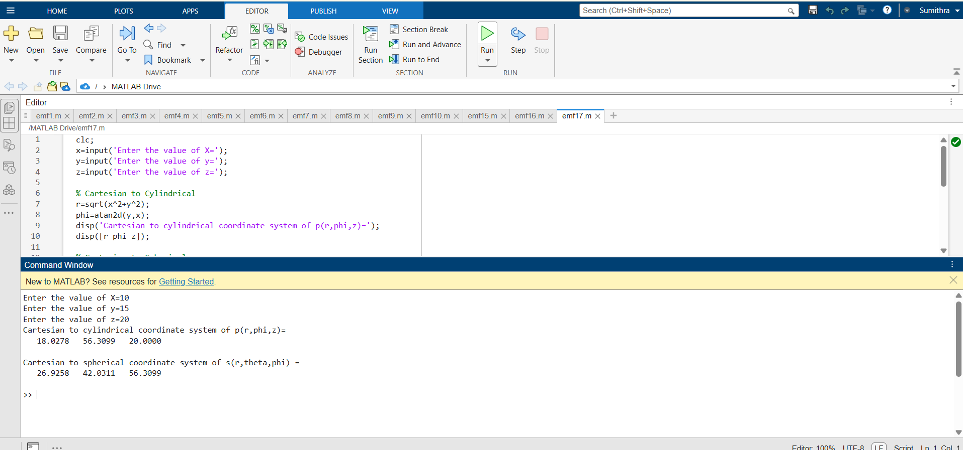
Test case (ii) Transformation of Cylindrical coordinate points into Cartesian and spherical coordinate system
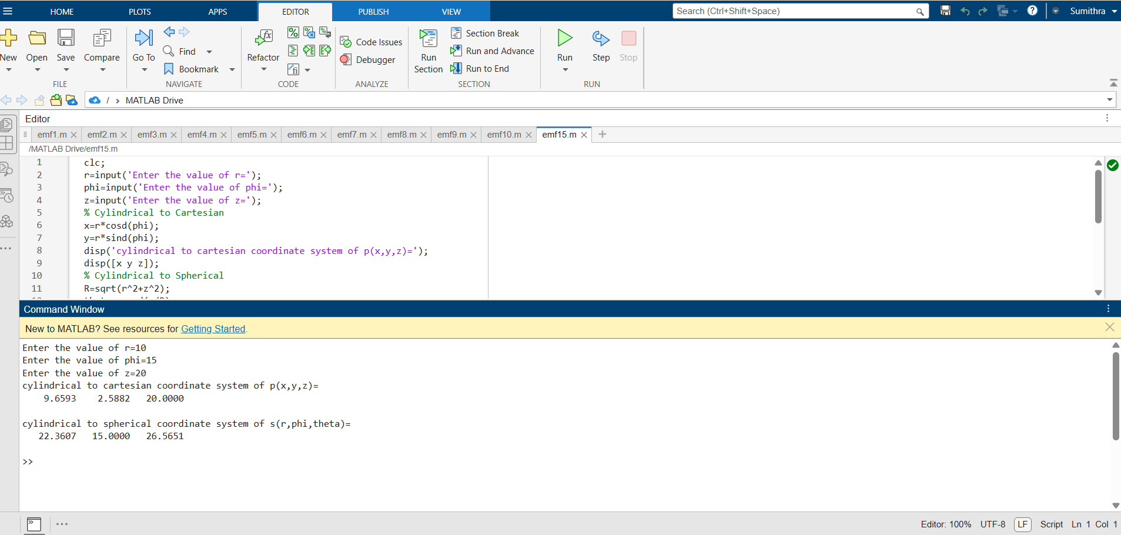
Test case (iii)Transformation of spherical coordinate points into Cylindrical and Cartesian coordinate system
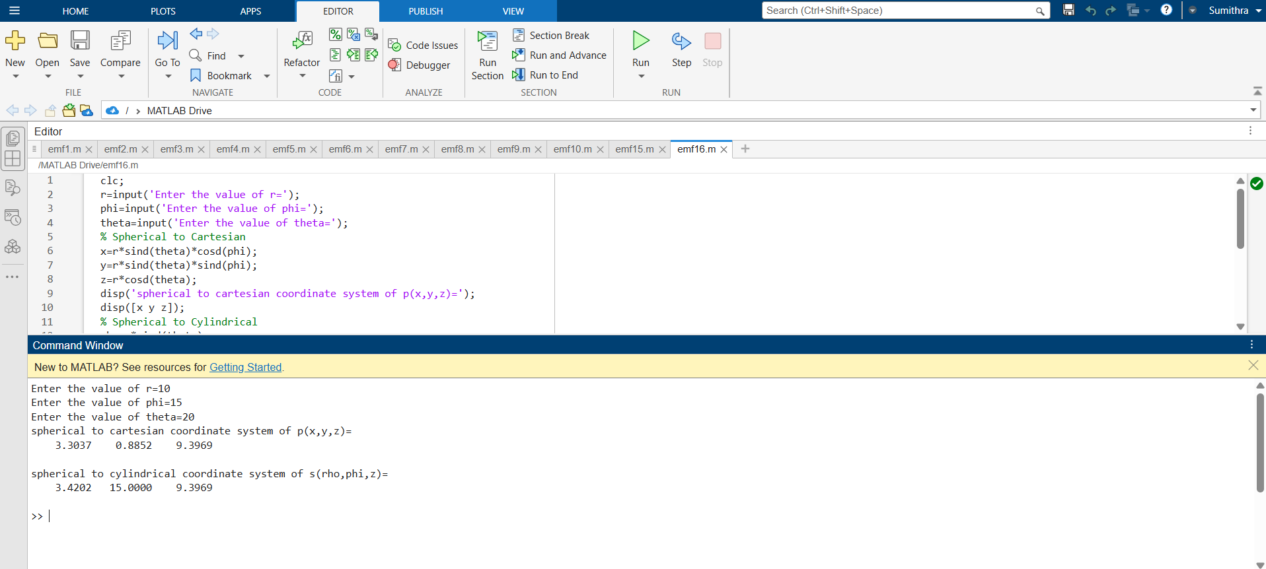
- Determination and plotting of Electric field and Electric flux density in sphere full of charges with varying radius.
Test case (i) Determination and plotting of electric field and electric flux density in sphere full of charges with varying radius
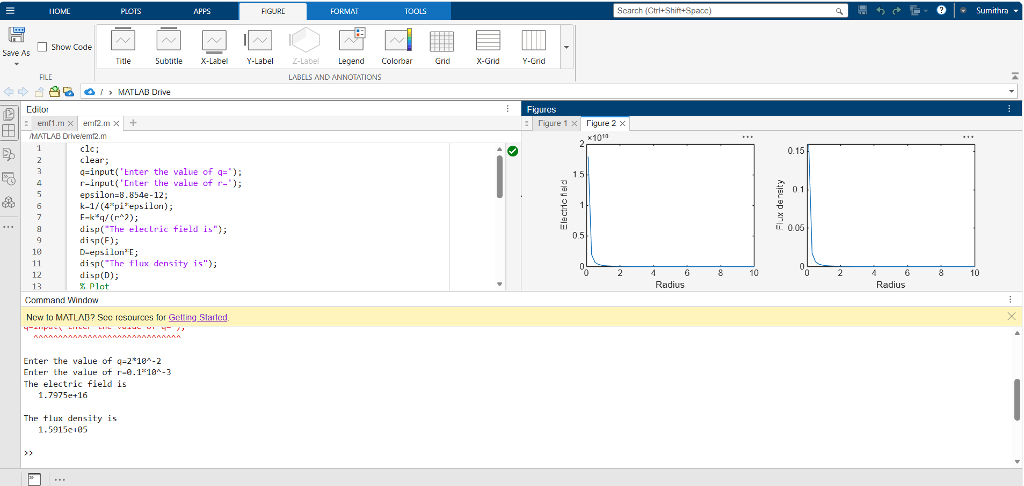

Test case (ii) Derive and plot the electric field (E) and electric flux density (D) inside a uniformly charged sphere with charge density ρ0
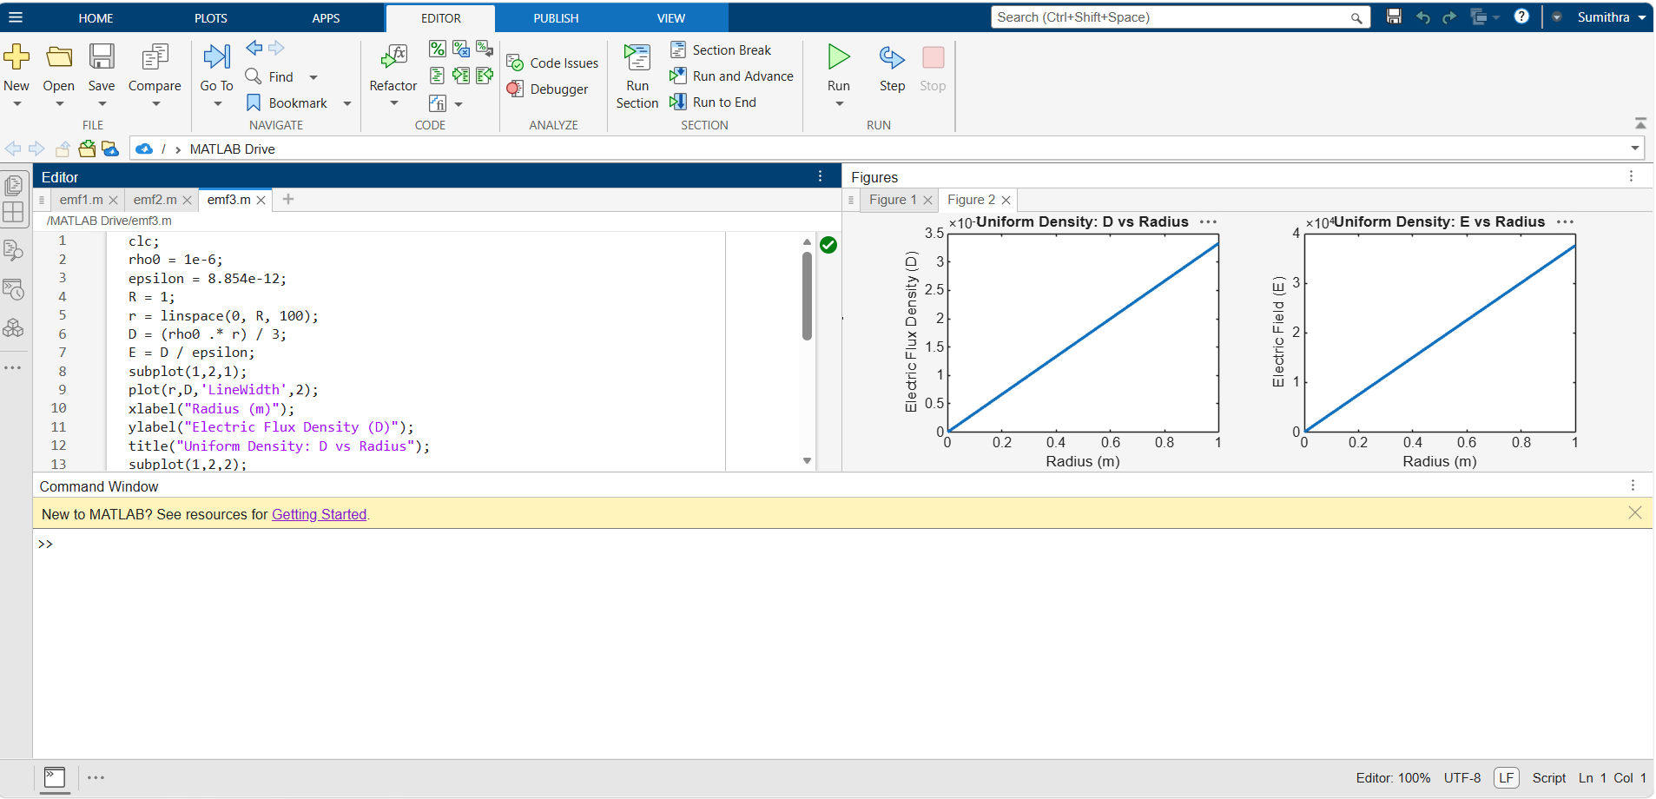
Test case (iii) For a sphere with a linearly increasing charge density ρv = ρ0r, derive and plot the electric field (E) and electric flux density (D)
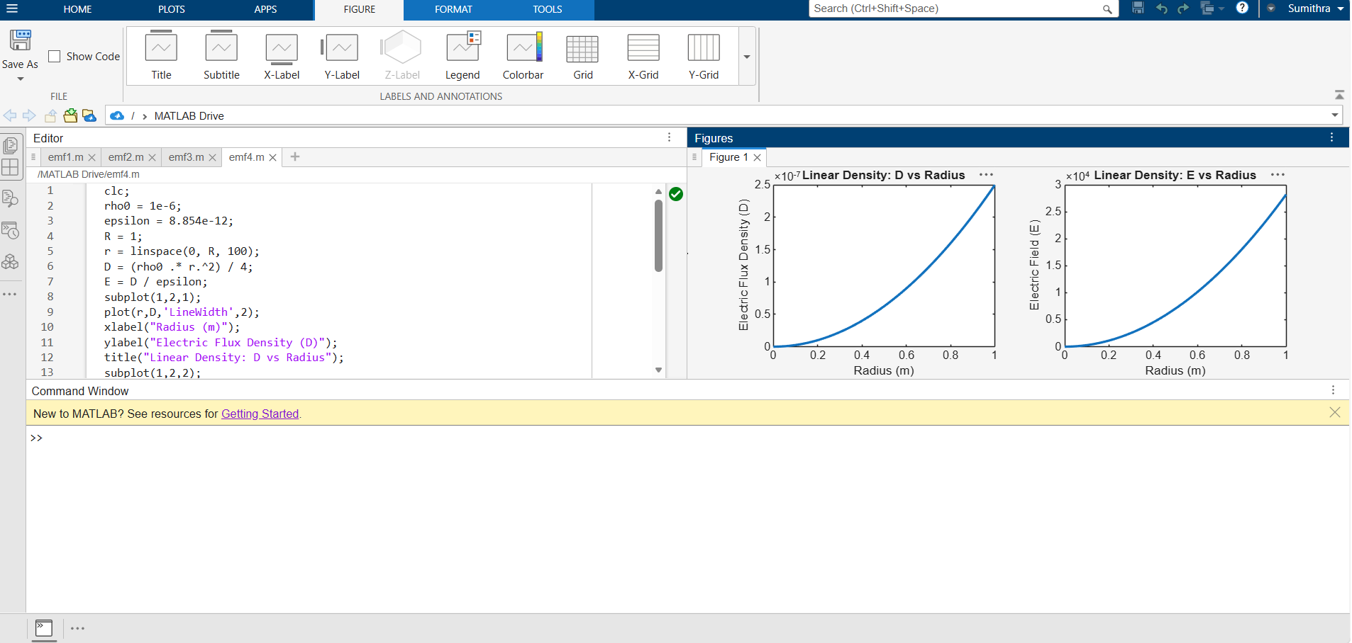

Test case (iv) A sphere of radius R = 2 m has a uniform charge density ρ = 3×10−6 C/m3.Calculate and plot electric field inside and outside the sphere
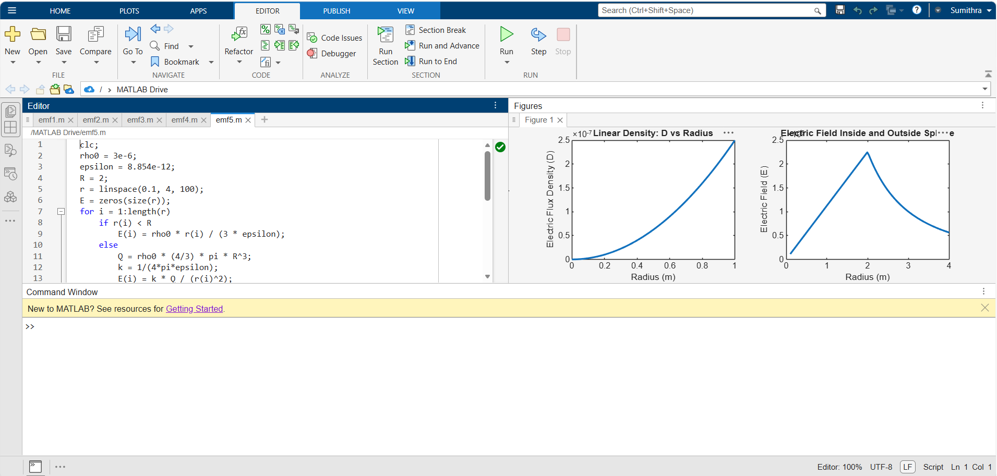
3.Determination and plotting of Force of attraction between two electric Charges and two parallel conductors separated by varying distance.
Test case (i) Determination and plotting of force between two electric charges with varying distance
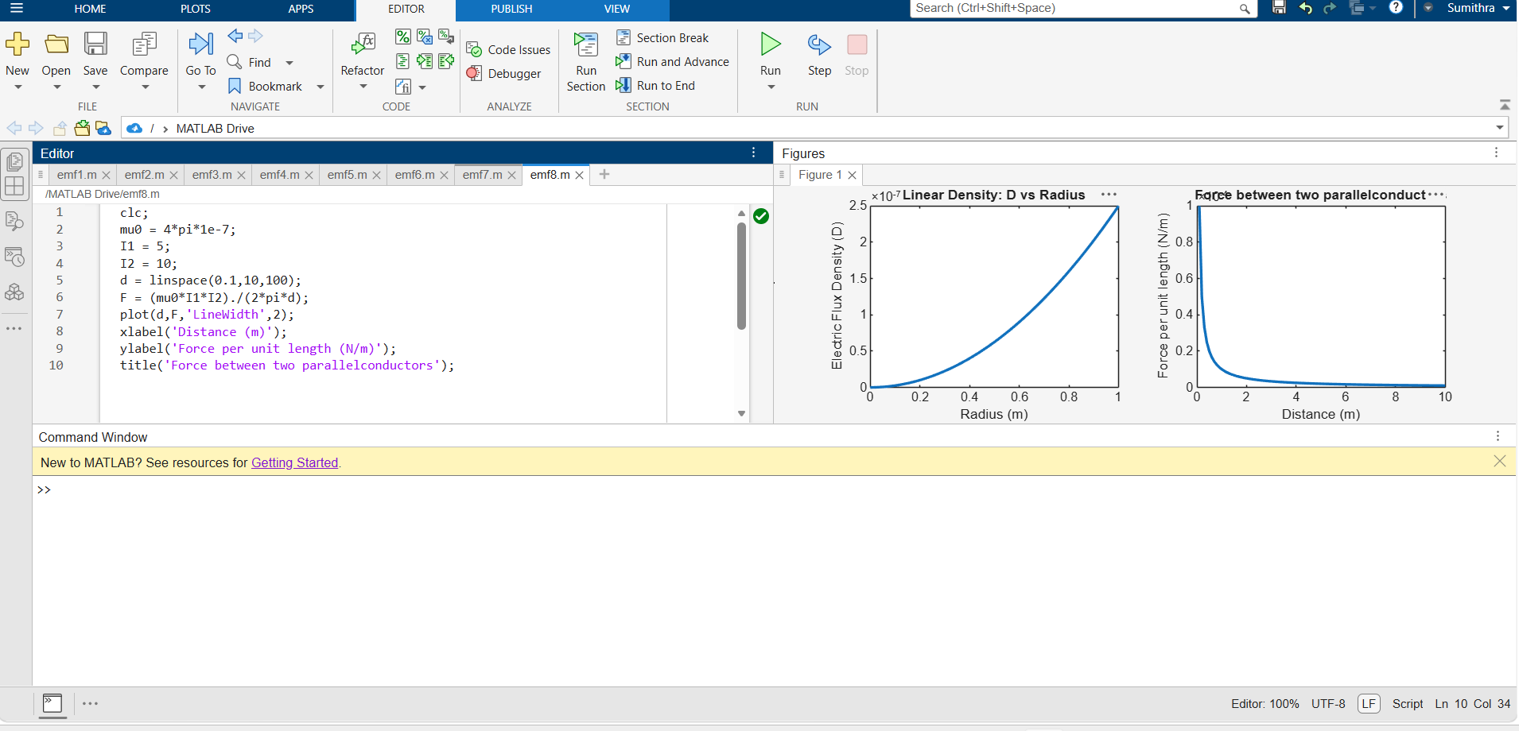

Test case (ii) Determination and plotting of force between two electric charges with different magnitudes
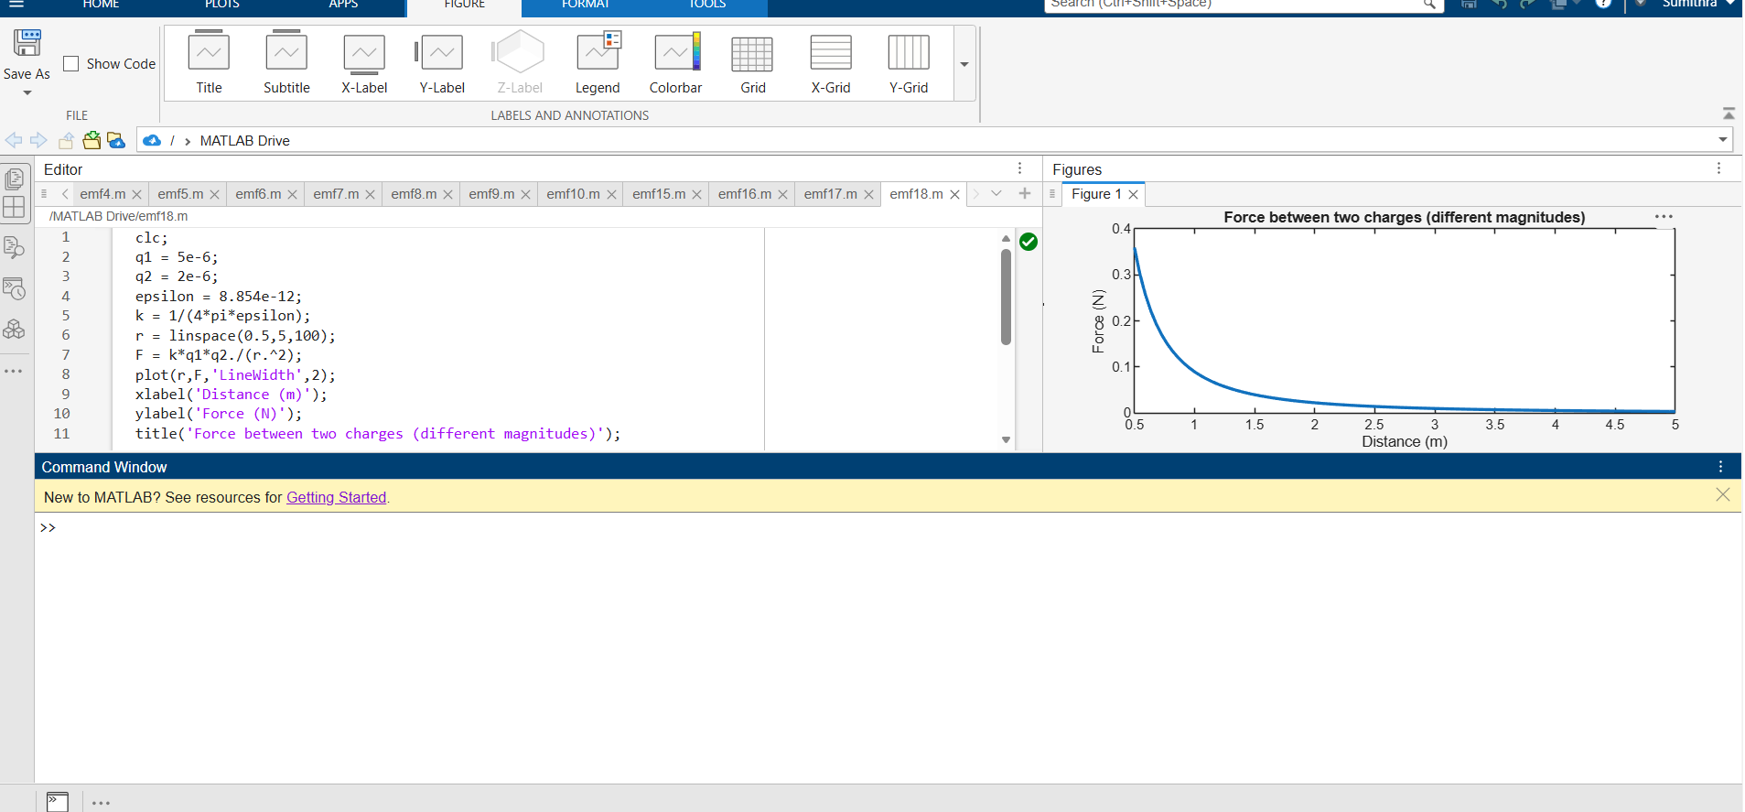
Test case (iii) Determination and plotting of force per unit length between two parallel conductors with varying distance
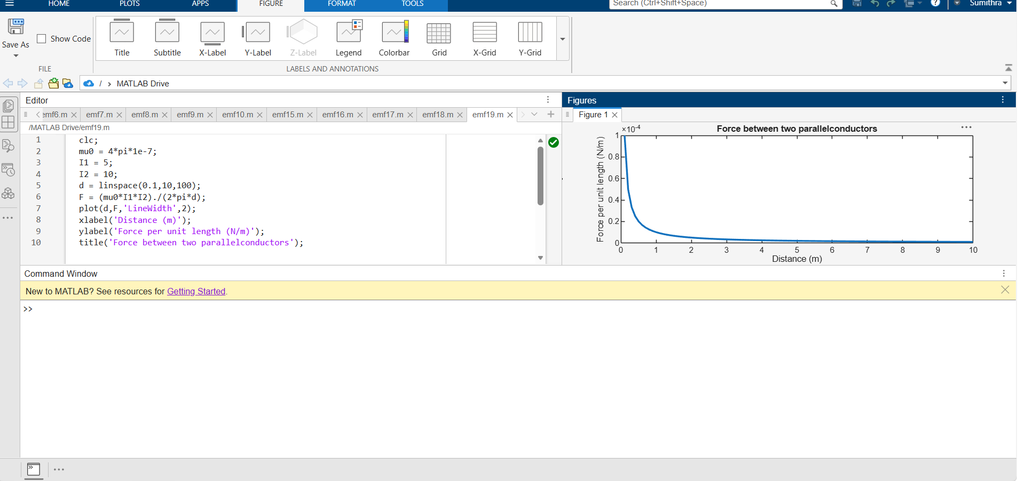

Test case (iv) Determination and plotting of force between two parallel conductors carrying equal currents
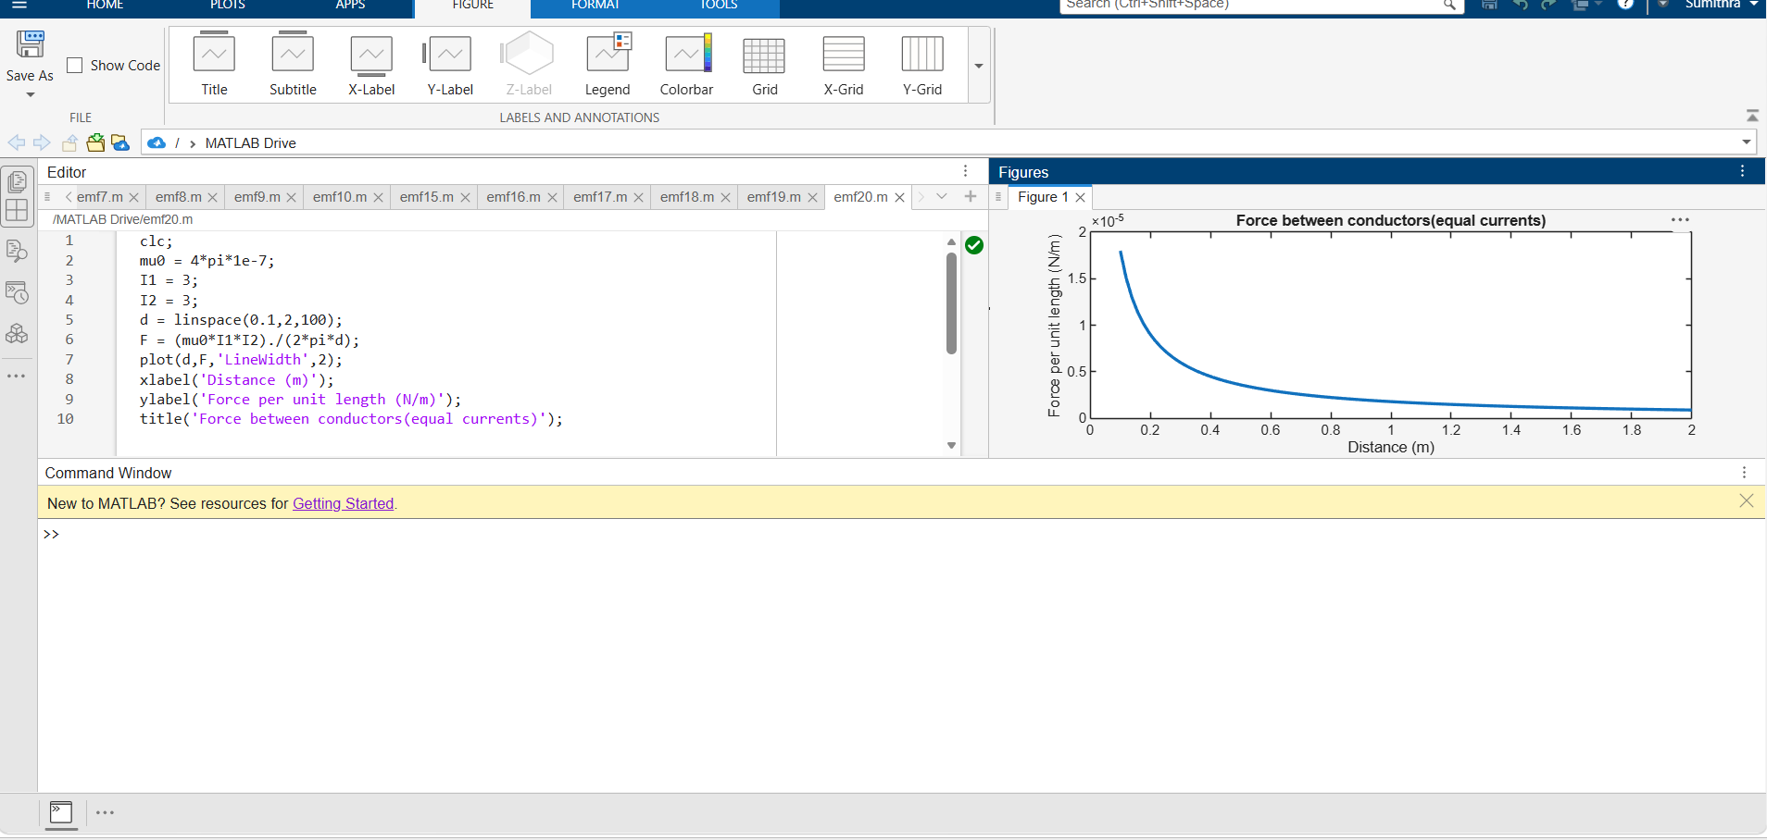
4.Analysis of Continuous Charge Distribution in electric field. To find the (i) line charge density, (ii) Surface charge density and (iii) Volume charge density for any specific (a) line, (b) surface or (c) volume.
Test case (i) Determination of line, surface and volume charge density for given charge, length and radius
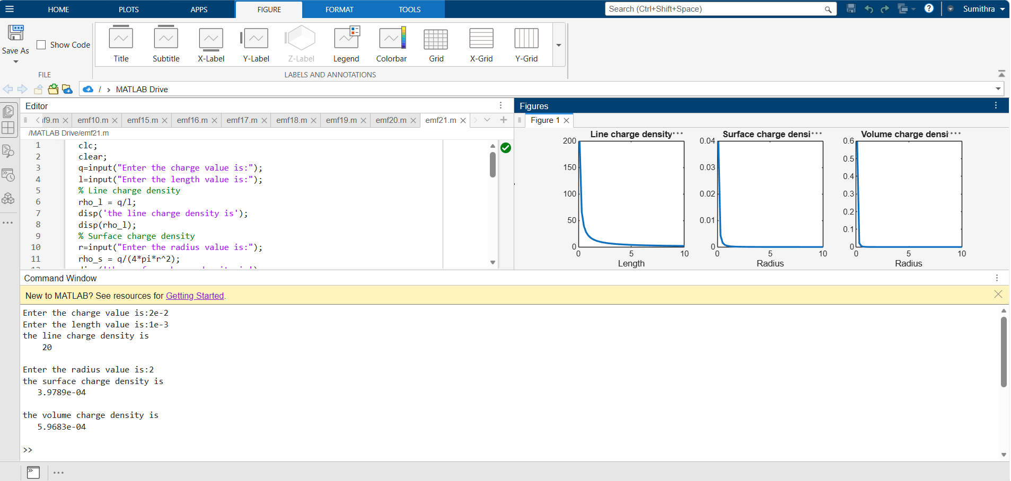

Test case (ii) A long wire of length L = 10 m carries a uniform charge of Q = 50 μC. Calculate the line charge density and plot electric field variation
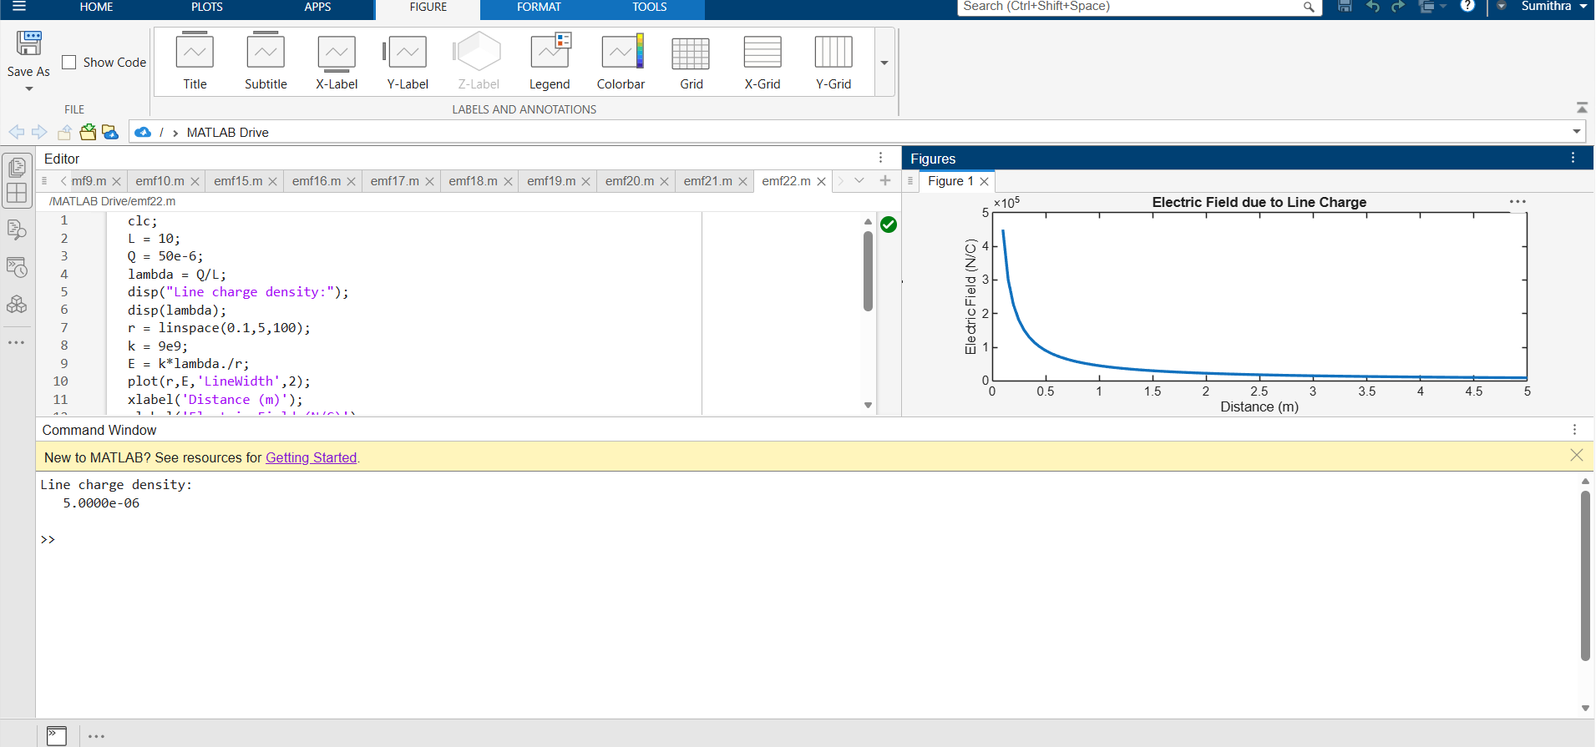
Test case (iii) A uniformly charged disk of radius R = 0.5 m with total charge Q = 10 μC. Calculate surface charge density and electric field
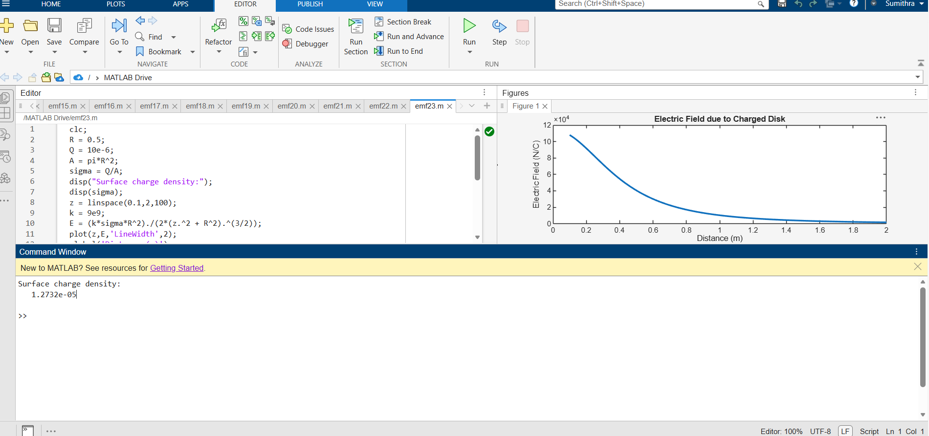

Test case (iv) A uniformly charged sphere of radius R = 2 m with total charge Q = 20μC. Calculate volume charge density and electric field inside and outside 3
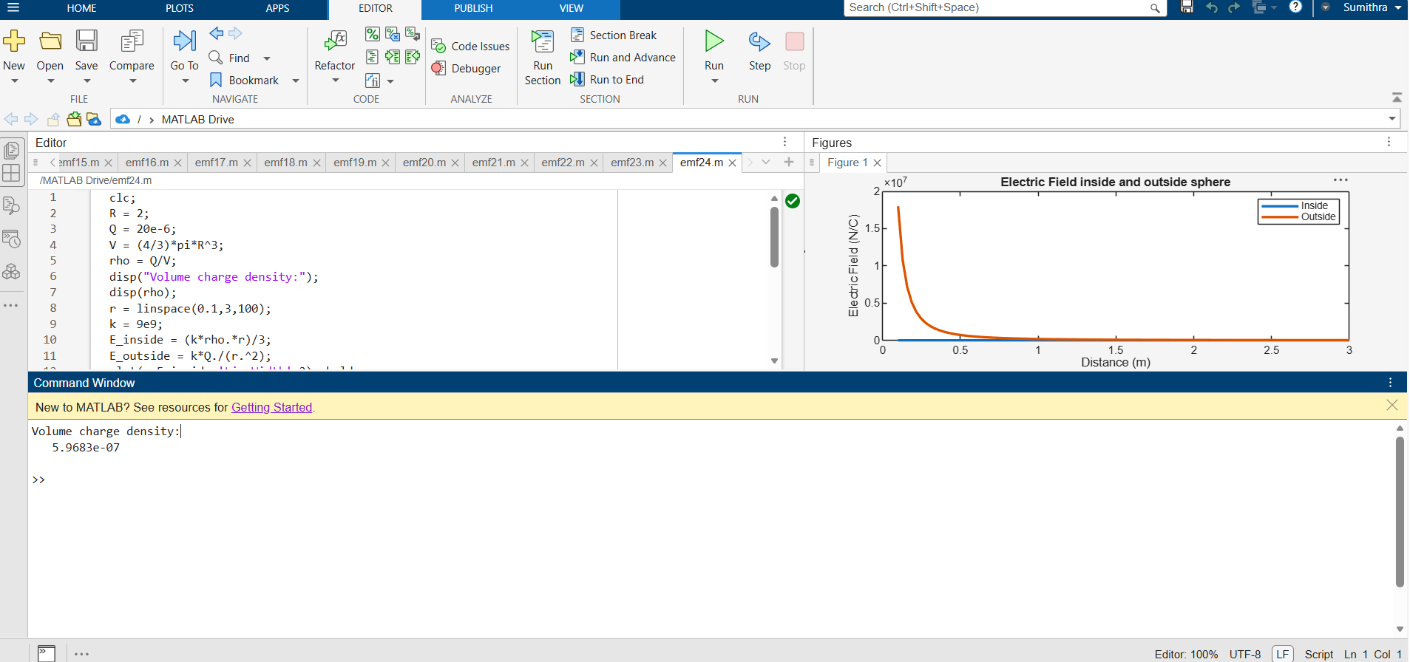
5.Determination and plotting of Electric potential difference between any two points in free space medium separated by a distance R.
Test case (i) Determination of electric potential difference between two points for a given charge
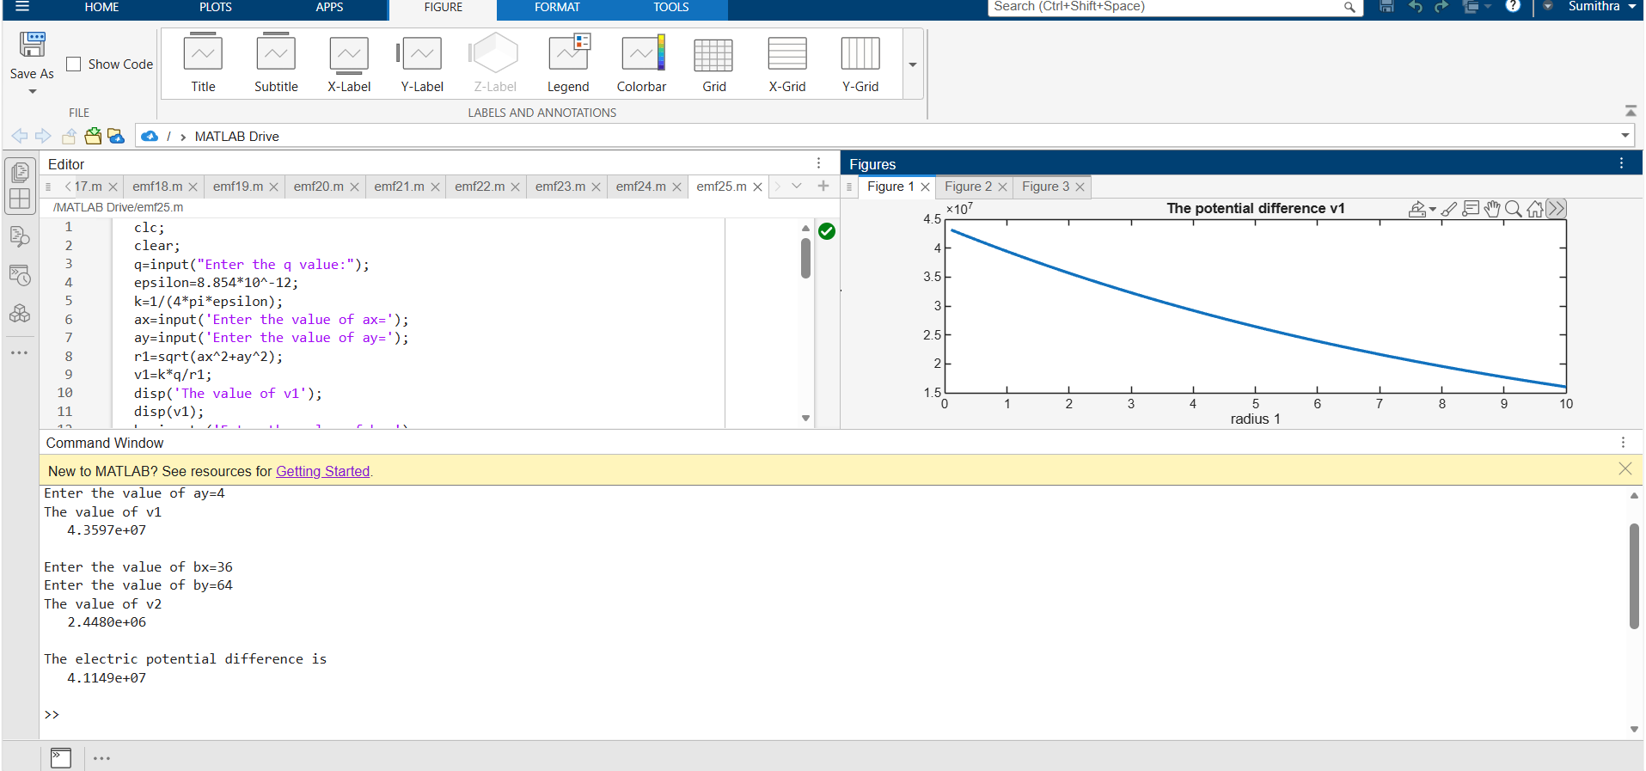

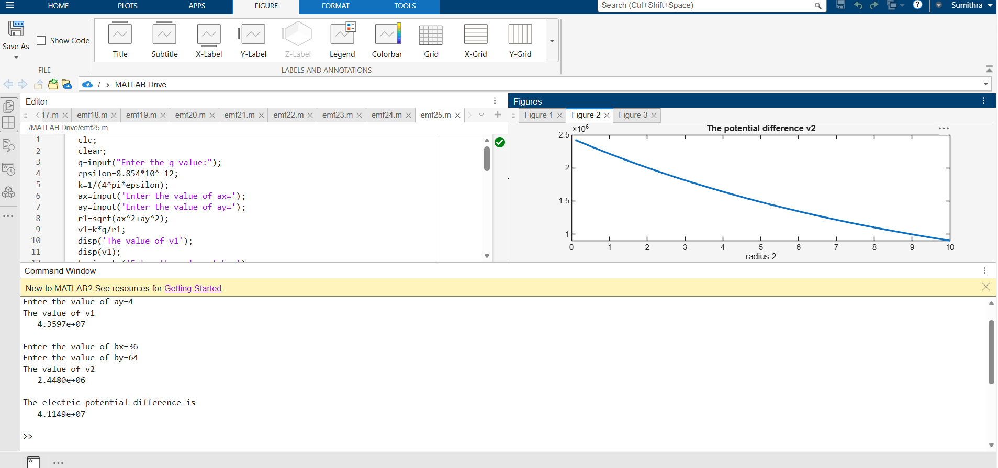
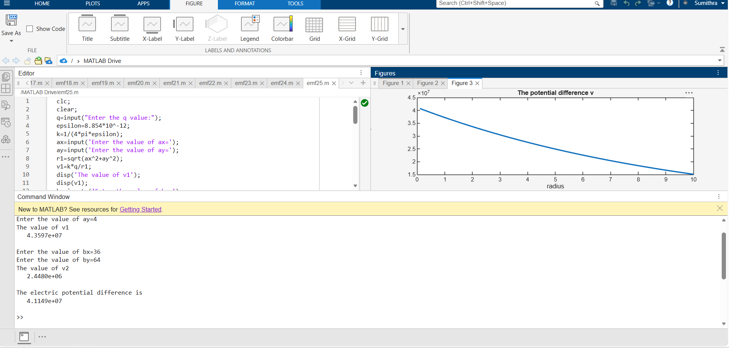
Test case (ii) A positive charge with fixed r1 = 1 m and r2 varying.
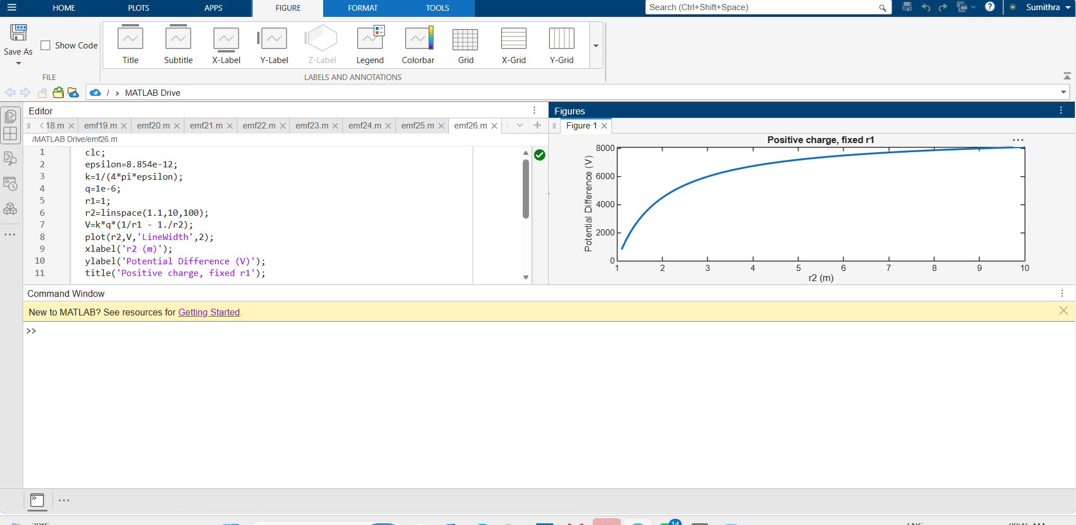
Test case (iii) A negative charge with fixed r1 and varying r2:
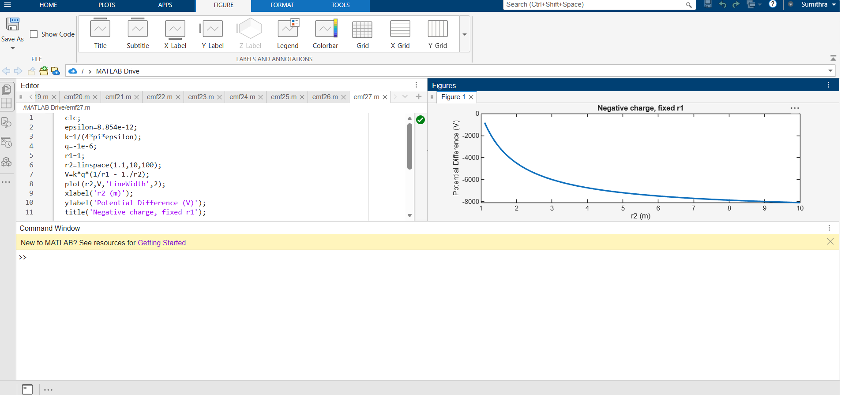
Test case (iv) Both r1 and r2 varying with positive charge 3:
